Malicious poisoning with Organophosphates or carbamate insecticides
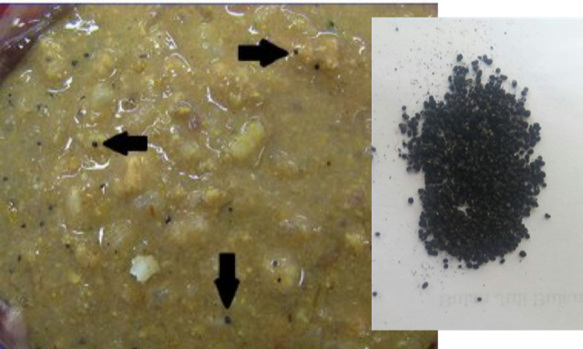
Carbamates and organophosphates are insecticides used in the agricultural industry. They are commonly used to poison pets maliciously. Poisoning can result from ingestion of food laced with the poison, which is often thrown over fences of target properties by criminals to kill the dogs protecting the property. The poison can also be absorbed by the skin of the pet or person.
However, modern malicious poisonings rarely involve only one product, but rather a combination of two or more. Sometimes unknown poisons may cause more severe effects on the body than conventional poisons and uncommon symptoms.
The common symptoms of poisoning:
- Sudden onset severe diarrhoea which is often bloody
- Sudden onset severe vomiting which is often bloody
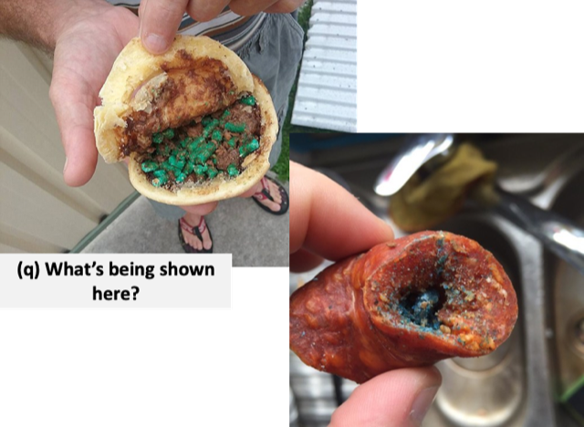
- Drooling (Increased salivation)
- Cramping
- Weakness
- Tearing (Lacrimation)
- Struggling to breathe (dyspnoea)
- Slow heart rate (Bradycardia)
- Muscle tremors, shaking
- Wobbling or difficulty walking (Ataxia)
- Seizures
- Dilated pupils
- Respiratory paralysis
- Difficulty swallowing (Oesophageal paralysis)
- Sudden death often due to respiratory failure
How does it work?
The poisons work at the level of small nerve communications. It blocks the nerve communication channels and leads to an accumulation of acetylcholine (neurotransmitter – nerve stimulator). This leads to increased and inappropriate activity by the nerves which causes the above-mentioned symptoms.

Immediate Action if you suspect your dog has been poisoned:
- If seizures present: place on his/her side on a soft, open surface (Protect the head).
- Do not attempt to put your hand anywhere near the dog’s mouth.
- Take your pet immediately to the vet for treatment.
  - Poisonings are life threatening and the symptoms cannot be managed at home.
  - Your pet needs immediate emergency treatment to increase the heart rate, stop seizures and improve blood oxygen levels.

What NOT to do:
- Do NOT handle saliva, vomit or diarrhoea without gloves on.
- DO NOT make your dog drink milk or eat raw egg.
- Do NOT give any oral medicines – poisoning can cause an inability to swallow and loss of consciousness which may cause your pet to choke and die if oral medication is given.
- Do NOT try make your dog vomit.
  - If you really cannot get to a vet within 30min and your dog is still conscious and able to swallow, the following can be done at your own risk:
    - Mix a small amount (1Tbsp) of washing powder with water to make a sticky ball.
    - Push the ball over the tongue and into the back of the mouth (like giving tablets) to make your dog swallow it.
    - This will induce vomiting.
    - NOTE: The washing powder can burn your dog’s mouth and throat and your dog may inhale the washing powder into the lungs.
    - USE GLOVES
- If you live close to a veterinary clinic, rather put your pet in the car and take immediately to the vet. The veterinarian can assist your dog to vomit safely or empty the stomach with a stomach tube.

What you MUST do:
- Immediately go to your nearest emergency veterinary clinic.
- Phone the vet when you are on the way so they can get emergency medications and equipment ready before you get there.
- Search the garden for any further poison and remove it- wearing gloves (do not touch vomit with your hands).

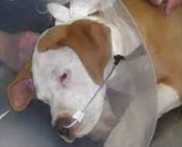
What your vet will do to help your dog
- The veterinarian will make your dog vomit safely using veterinary registered medication (only if the poison has been ingested in the last 1 hour and no clinical signs are present).
  - If your pet is already symptomatic and it is not safe to induce vomiting, the veterinarian will sedate your pet to place a stomach tube to manually empty and flush the poison from your pet’s stomach. This is important to stop any further poison from entering the blood stream.
- Emergency treatment will be implemented as necessary. This includes fluid therapy, medication to increase the heart rate and supplementing oxygen. In severe cases your dog may need to be intubated (tube into the trachea) and manually ventilated.
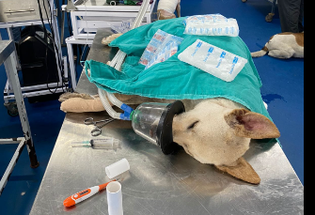
- If the dog is seizing, anti-seizure medication will be given to attempt to stop the seizures. Muscle relaxants are also administered to stop muscle tremors or spasms.
- Patients frequently need to be admitted into hospital for supportive care and treatment for at least 48 hours. This usually includes:
  - Fluid therapy
  - Activated charcoal to bind the toxin in the digestive tract.
    - In severe cases a special intravenous medication (Intralipid) is used to bind toxins already in the blood.
  - Anti-nausea medication to stop your dog vomiting up the activated charcoal and assist the digestive tract to maintain normal movement.
  - Muscle relaxants to stop the muscle tremors.
  - Nutritional support.
  - Intensive monitoring to pick up on any complications and recirculation of poison which may occur.
  - Occasionally excess stomach fluid needs to be removed from the stomach using a stomach tube.
  - Oxygen therapy in severe cases.
  - Ventilation if required.
  - Anti-seizure medications.
- In the event of a severe poisoning, especially if veterinary care is delayed, the prognosis (outcome) is very poor. The veterinarian will guide you in your decision regarding treatment options and your pet’s prognosis.
- Even though all possible treatment is given, there is always a chance that your pet might not survive being poisoned. In some cases, humane euthanasia may be the only option.

Should you need assistance with a poisoning please phone Bakenkop Animal Clinic. Bakenkop Animal Clinic is available 24 hours for emergencies.

Business hours number: 012 653 4474/2
After hours Emergency number: 082 5511 966

